Driver Handbook

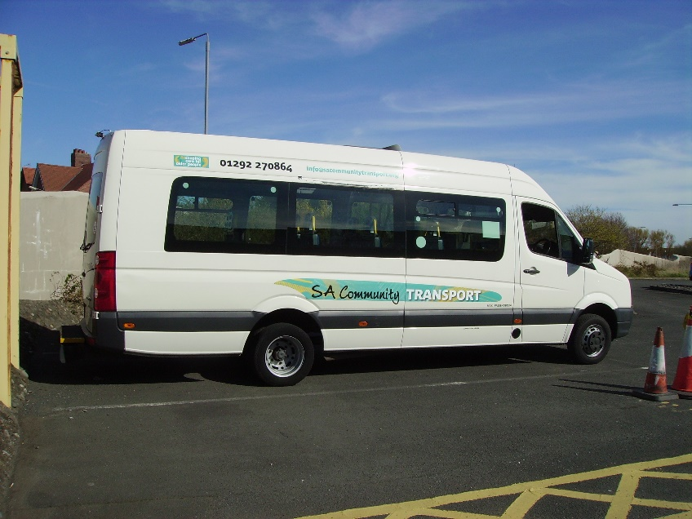

SACT
Driver Handbook
SACT is a member of the West of Scotland Community Transport Network
SACT is based at 27-29 Crown Street, Ayr KA8 8AG
Email: info@sacommunitytransport.org
Web: www.sacommunitytransport.org

Personnel
Community Transport Manager Catriona Haston 01292 270864
Community Transport Administrator Mike Ross 01292 270864
Finance Officer Lesley Ness 01292 270864
Electric Car Club Assistant George Dickie 01929 270865
Office hours are 09.00 – 17.00 Mon – Fri

Sickness Reporting
If you are sick and are on the rota to work, we would be very grateful if you could contact us as early as possible to allow us to find alternative cover.

Holiday Requests
If you are going on holiday or there are any long spells where you are likely to be unavailable, you are asked to please inform us as soon as possible. Casual staff are not entitled to paid holidays

Vehicle Defects Procedure
All drivers must complete a vehicle check before and after every journey undertaken. Any defects should be logged on the sheets provided in the vehicles and the Administrator or CT Manager advised where repairs are required. The daily checks to be undertaken are detailed on the sheets provided. Please pay particular attention to tyres.

Journey Log Sheets
All drivers must complete a Journey Log Sheet for every journey undertaken. These are provided in the vehicles. Mileage must be noted at the beginning and end of ALL journeys and all sheets must be signed by the driver

Late Returns
If you will be returning to base after the office is closed, please place the keys in a brown envelope (provided), seal it and post the envelope through the door of the Office where it will be collected by staff in the morning. DO NOT UNDER ANY CIRCUMSTANCES POST MONEY IN THE ENVELOPE. Please retain any moneys and bring to the office the following day

Driver timesheets
All drivers are required to complete their own timesheets and submit them fortnightly on the Monday of the week when payment is to be made

Road Behaviour

All drivers are required to stick strictly to the rules of the Highway Code at all times. Drivers should remember that the reputation of SACT, and the safety and comfort of the passengers they are carrying, depends to a great extent on their driving behaviour. Lane markings and road signs must be strictly adhered to. Any incident involving SACT vehicles must be reported immediately to the Community Transport Office and the police and/or insurance company if required. Contact details are provided below and in all SACT vehicles.

Drivers must under no circumstances exceed the speed limit. Speed limits are the maximum speed for a particular stretch of road or area. In some places it is inappropriate to reach the maximum speed limit allowed and the road and weather conditions must be taken into account. For example, when driving near schools or in housing schemes, or in heavy rain or fog drivers should reduce their speed.

Seat Belt Information

Passenger | Front Seat | Rear Seats | Who is responsible?
Driver | Seat belt MUST be worn | N/A | Driver
Babies and children under the age of 3 | Suitable car seats MUST be provided by the parent/ guardian and used at all times | Suitable car seats MUST be provided by the parent/ guardian and used at all times | Parent/guardian and driver
Child from 3rd birthday up to 135cm (4’5”) in height or 12th birthday | Correct child restraint MUST be used | Where seat belts fitted, correct child restraint MUST be used | Driver
Child over 135cm (4’5”) or 14 years of age | Seat Belt MUST be worn | Seat belt MUST be worn | Driver
Adult passengers | Seat belt MUST be worn | Seat belt MUST be worn | Passenger*

*Please note – we advise drivers to insist that ALL passengers, without exception, are wearing seat belts before setting off. If passengers later remove seat belts, drivers are advised to pull over in a safe place, advise passengers to fasten safety belts, and to stay there until all passengers are belted in safely. If there are further problems, please ring the office 01292 270864 for advice.

Use of Mobile Phones while Driving

- DO NOT UNDER ANY CIRCUMSTANCES use a mobile phone or other handheld equipment while you are driving
- If you have to use a phone, pull over, park safely, put the handbrake on and switch the ignition off before you use the phone
- Do not text or try to read texts while you are driving.
- Do not allow passengers to hold a phone to a driver’s ear to make a call, or listen to a message while driving
- It is better to switch your phone off or put it on voice mail while you are driving

THE LAW
Drivers will get an automatic fixed penalty notice if caught using a hand-held phone while driving or riding. Drivers will also get 6 penalty points on their licence and a fine of £200 for which the driver is responsible. In some cases, the driver could be taken to court, be disqualified from driving and incur a maximum fine of £2500.

Driving under the Influence
Driving under the influence of alcohol or illegal drugs will not be tolerated under any circumstances. Drivers involved in any incident where it is proven that they are over the national drink driving limit or driving under the influence of illegal drugs will be instantly dismissed; or in the case of sessional or volunteer drivers, will be prevented from ever driving SACT vehicles at any time in the future.
If you have been prescribed drugs by a doctor which may impair your ability to drive, you must let the office know immediately so that cover can be arranged.

Overmills Day Centre Service Details
Overmills Day Care Centre
Westwood Avenue,
Ayr
KA8 0QZ

Bus Pickup Time (morning) | 8.30 am
Bus Pickup Time (afternoon) | 1.30
Bus Pickup Point (SACT drivers) | John Pollock Centre
Drivers | Only SAC approved drivers
Overmills contact tel. no. | 01292 610225
Bus needed | SACT 3 or SACT 4
Set up for bus | Generally one wheelchair space but as per requirement on day
Destination | Various Ayr locations

SACT ‘Out and About’ Excursions
Driver Check List
Before:
- Research venue including disabled access/facilities
- Plan route including possible comfort break stops
- Identify drop off and parking places
- Get (or print from internet) guide leaflets/maps etc
- Week before - confirm passenger details, plan pick up route and times, advise office so they can call passengers.
- If there are any new members going on the trip make sure you have a membership application form

On the day: Outward
Double check passenger list for cancellations/reserve list substitutions
- Check bus set up correctly for seated/wheelchair passengers and that there is enough room to secure any walkers and trolleys
- Introduce people as they come on board and encourage those already seated to chat/introduce themselves
- If the trip has optional destinations, confirm with each passenger which one they want
- When all passengers are on board have a quick chat about the plan for the day, whether or not comfort break is planned, rough timings, hand out any leaflets and membership application forms, collect fares from those who have not paid in advance; or, if running behind, this can be done on arrival, over lunch or at return pickup.
- Emphasise safety and comfort
  - seatbelts must be worn at all times
  - stress that passengers must tell driver if there is any problem or anyone is feeling unwell. The driver can stop if needed or divert to A&E if required
  - check whether passengers need windows open/heating on and ask again during the journey
- On arrival, agree return pick up place and time. Make sure everyone has heard/understood/agreed before they get off the bus
- Pick up copies of venue info leaflets/maps for use on future excursions

On the day: Return
- Check if anyone wants to be dropped off somewhere different from pick up, and plan drop off route/order
- Collect in any forms and fares, check off against passenger list and note any discrepancies
- Repeat safety and comfort chat
- Ask for feedback on the venue, timings etc., any suggestions for future trips and pass round the feedback book (or this can be done over lunch if everyone is together)
- Remind people to take all their personal belongings - especially if they have put anything in the top box

After the trip
- Check that no personal belongings have been left on board
- Take fares and passenger list in to SACT office with note/explanation if amount is different from total on sheet
- Pass on any driver and passenger feedback

Group Hire of SACT Vehicles

Conditions of Minibus Use
- Groups or organisations must be affiliated to South Ayrshire Community Transport (SACT)
- All drivers must be registered with SACT
- Driver registration to be renewed annually. Driving licence will be checked on registration. SACT retains the option to refuse registration
- New drivers must be given a familiarisation course on the vehicles and agree to take part in MIDAS training within the next 12 months
- Drivers must be over the age of 21
- Drivers must have a D1 on their license to be able to drive heavier SACT buses
- Vehicle charges may vary throughout the year. Refer overleaf for details
- On completion of each hire Journey Log sheet, which records the mileage and passengers numbers, must be completed and returned with the vehicle keys to the hire base
- Any accidents or damage to the vehicle must be reported on the mileage form and verbally to the hire base. Where possible details of any witness (including passengers) to the incident are to be written on the back of the mileage form. After an accident or any damage, the SACT committee may not allow the driver to use the vehicles until the situation has been investigated. Where negligence has been proven the group will be responsible for the cost of any repair
- SACT will not necessarily meet any costs resulting from the engagement of garage services by any user group for whatever reason
- The vehicle is to be left in a clean and tidy condition. Failure to comply will result in a £30 charge being added to the invoice
- SACT can take bookings for up to 6-week period, which can be reviewed at this point
- All vehicles have breakdown membership that covers breakdowns and emergencies. User groups using minibuses do so at their own risk. SACT cannot be responsible for any additional costs encountered
- Safety of operation and the well-being of our users is the prime concern of SACT. SACT reserves the right to suspend the affiliations of any group or the registration of any driver, without liability or re-imbursement
- The number of passengers designated for the vehicle must not be exceeded
- Seat belts and wheelchair straps must be used at all times
- When parking the vehicle on return, ensure that common sense prevails so that other vehicles are not blocked in

Bookings can be made by:
- Email – info@sacommunitytransport.org
- Telephone: 01292 270864
- In Writing: South Ayrshire Community Transport, 27-29 Crown Street, Ayr KA8 8AG

MiDAS Training

All drivers must be over 21 & have a D1 on their licence (to drive 10+ seaters) and agree to complete MiDAS (within one calendar year) in order to drive the SACT Minibuses if they have not already done so. A refresher course is required every 4 years. Drivers wishing to arrange MIDAS or D1 training should contact Mike on 01292 270864

Protection for Vulnerable Groups
All drivers employed by SACT must have, or agree to have PVG certification. SACT will bear the cost of obtaining PVG certification for employees. This is mandatory for all SACT paid drivers. Contact the office for more information on 01292 270864. Community groups providing their own drivers are responsible for making their own arrangements.

Bus Breakdown Information
In the first instance, please always ring the office if in normal working hours.
SACT Office (Mon – Fri, 9am-5pm) – 01292 270864
If outwith office hours, please contact Greenwood Moreland Insurance Consultants Ltd. Tel: 0141 779 1801. Insurance details can be found in the vehicles. The insurance underwriter is Equity Red Star (ERS) and the fleet insurance policy number is 50071694.
ERS Breakdown 0800 587 8872 or 01277 720778
QBE Breakdown 0800 389 1708
They will ask for the following information:
- Driver Name & location
- Registration Number
- Colour of Vehicle
- Model of Vehicle
- Description of Fault
- Vehicle Mileage if known
- A Telephone Number to contact driver on
Accident Policy
Passenger Accidents
- Should an accident occur to any passenger being carried on SACT vehicles, the driver must take the appropriate immediate action (i.e. call for medical aid (999), divert to A&E, return the passenger home, inform the Day Centre of the incident etc. as required)
- On returning to the office, the driver must report the incident to the Community Transport Manager and/or Administrator
- An Accident/Incident Report Form must be completed by the person receiving the report. The forms are kept in the SACT office and must be signed by the Community Transport Coordinator, their line manager and the driver of the vehicle concerned
- An Accident and Incident record is kept in the SACT office
- Every employee has a duty to report incidents, to assist in determining the cause and to help in any subsequent investigation with the aim of preventing any recurrence
- Every employee has a duty to report any procedure or piece of equipment considered unsafe and to make recommendations on improved safety measures
- In the case of an accident involving a child, the Accident and Incident Record must be completed, signed by a member of staff, witnessed by a member of staff and signed and dated by the parent/guardian. The parent/guardian should receive a copy
Vehicle Accidents
- The driver must first ensure that all passengers are safe and uninjured. If there are any injuries, the above procedure must be followed
- The driver must report the incident to the Community Transport Coordinator or their line manager as quickly as possible – 01292 270864/07708 871386/07878 912078
- If another vehicle is involved, do not admit liability
- Take photographs where possible of the damage to your, and any other vehicle involved
- If the vehicle is safe to drive, take advice from the office. The run may continue or you may be instructed to return to base
- If the vehicle is not safe to drive, the office will arrange for uplift and the onward transport of any passengers
- On returning to the office, the driver must report the incident to the Community Transport Coordinator or their line manager
- An Accident/Incident Report Form must be completed by the person receiving the report. The forms are kept in the SACT office and must be signed by the Community Transport Coordinator, their line manager and the driver of the vehicle concerned
- An Accident and Incident record is kept in the SACT office
- Every employee has a duty to report incidents, to assist in determining the cause and to help in any subsequent investigation with the aim of preventing any recurrence

First Aid
- First Aid facilities are provided in the form of a First Aid Box placed in every vehicle. All staff must always wear gloves when administering First Aid. Where possible we will look to have drivers trained in administering first aid.
- Biohazard kits are also available in every vehicle

and finally….
Confidentiality
SACT works with many people, among them children and vulnerable adults and employees will sometimes be in contact with confidential information.
SACT drivers (paid and volunteers) will respect confidentiality in the following ways:
- Drivers will not discuss the individual clients/passengers other than for purely operational reasons
- SACT drivers (paid and volunteers) will maintain strict professional boundaries at all times
- If a driver has any anxieties/evidence relating to a child’s, or vulnerable adult’s personal safety, this must be reported to the CT Manager immediately. The information will be kept in a confidential file and will not be shared with anyone in the company except with the managers (please see Child and Vulnerable Adult Protection Policy)
- Any personal information will not be passed on to anyone else without explicit permission
- The discussion of work-related activities and/or confidential information on social networking sites will not be tolerated and will be subject to disciplinary action by management – (please see Social Networking Policy)
SACT drivers will at all times comply with all requirements of the Data Protection Act.

Please note: SACT policies on Code of Conduct, Capability, Grievance, Disciplinary, Bullying and Harassment, Protection for Whistleblowers, Health and Safety, Workplace Drugs and Alcohol, Child Protection and Procedures, Vulnerable Adults Protection and Social Networking are available to view and download on the website.
https://sacommunitytransport.org/driver-information/
. Hard copies are available from the office on request.

